Andrew Michael Maxey
Family History in America: 1691 - 1952

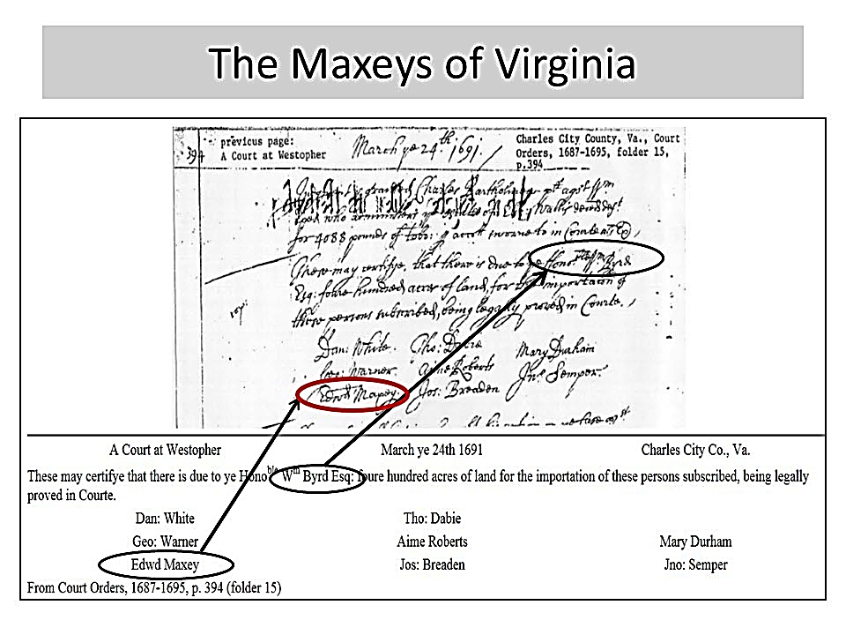
I am descended on my father’s side from Edward and Susannah Maxey of Virginia. The first record of Edward Maxey was in a Charles City County court document showing him as part of a contingent of eight indentured servants brought to the colony in 1691 by William Byrd I. The court order was filed on March 24, 1691, and listed Edward Maxey as one of eight people for whom Byrd paid passage to the colony. He was due fifty acres for each person, totaling four hundred acres. Over his lifetime, Byrd paid the passage for approximately six hundred people, obtaining 30,000 acres under the headright system. Edward Maxey would have served a five to seven-year term, most likely at Westover Plantation located on the James River at 7000 Westover Road, Charles City, Virginia. Byrd began building his home at Westover in 1689.

The Maxey family originated in England as early as the 11th century. Organ Maxey was identified as a resident of Chesire in “The History and Antiquities of the County of Essex,” printed in 1768. The Maxeys of Virginia states: “There is no doubt our progenitor, Edward Maxey, came from the British Isles.
After he arrived in 1691, Edward Maxey is found in the colonial records again twenty-nine years, in 1720, where Henrico County court records show that a bounty of one hundred pounds of tobacco was paid for a wolf’s head killed by “Maxey’s negroes.” By this time, most of his eight children should have been born. I am descended from Walter Maxey, the youngest of his eight children.
Children of Edward & Susannah Maxey
- EDWARD MAXEY, JR.; d. 1726, Henrico Co., Va.
2. SUSANNAH MAXEY; m. William Barnes.
3. ELIZABETH MAXEY; m. John Radford.
4. JOHN MAXEY; d. after 1779, Buckingham Co., Va.
5. WILLIAM MAXEY; d. 1768, Cumberland Co., Va.
6. NATHANIEL MAXEY; d. 1779, Powhatan Co., Va.
7. SYLVANUS MAXEY; d. 1770, Prince Edward Co., Va.
8. WALTER MAXEY; d, 1791, Franklin Co., Va.

Walter Maxey, Edward and Susannah Maxey's youngest child, was found to be living in 1738 on Flat Creek in Amelia County, Virginia, according to a tithe record. By the terms of his father’s will, he received one-half of the land in Goochland County (later Cumberland County) after the death of his mother. In 1748, his brother Sylvanus deeded him the remaining 200 acres of the patent. Walter lived on his land until 10 December 1762, when it was sold. He moved with his family to Bedford County, Virginia, in 1785 (later Franklin County). Walter purchased 528 acres from Samuel and Grizel Smith in 1763 on the Staunton River's west and the Blackwater River's north sides. Walter was the last surviving child of Edward and Susannah. The original copy of his will and other probate records are on file at the Rocky Mount courthouse. Walter’s children are listed as the “8” as descended from the eighth child of Edward and Susannah Maxey.
Children of Walter and Mary Maxey
81. JANE MAXEY; m. John Craghead.
82. JOSIAH MAXEY; d. 1793, Franklin Co., Va.
83. JEREMIAH MAXEY; d. 1810, Oglethorpe Co., Ga.
84. JESSE MAXEY; d. ca.1808, Sumner Co., Tenn.
85. WALTER MAXEY, JR., b. 6 July 1745, Goochland Co., Va.; d. 7 Oct. 1828, Jasper Co., Ga. [The birth date is given as 9 July in the son Pouncey’s Bible.)
- MARY MAXEY; m. Walter Addy.
- LUCY MAXEY; m. William Cowden.
- SUSANNAH MAXEY; m. John Sullivant.
89. ESTHER MAXEY, b. 14 Nov. 1761, Cumberland Co., Va.; d. 20 May 1826, Franklin Co., Va.; m. Thomas C. Kemp.

I am descended from Walter’s fourth child, Jesse Maxey. The earliest record of Jesse Maxey was a statement found in Cumberland County, Virginia, court record of 24 July 1769: "The attachment obtained by Nathaniel Maxey against the estate of Jesse Maxey who is said to be so absconded that common process cannot be served upon him for 3 pounds 10 shillings said to be due from the said Jesse to the said Nathaniel by his attorney. At about that time, Jesse was supposed to have been in New River, Botetourt County, Virginia — now located in Pulaski County near the Montgomery County border. His name was on a list of tithables for the lower district of New River, Botetourt County, in 1771. Jesse served in the American Revolution as a private in the Lincoln Militia under Captain Samuel Kirkham, guarding the salt works from 22 September through 21 October 1782.3 For his service — there may have been more than the month indicated — he received 640 acres in 1783 located on the east fork of Station Camp Creek in what was to become Davidson County, Tennessee. This apparently was the state of North Carolina grant #13 for this land allotted to him as one of the chain carriers for laying out tracts for the officers and soldiers of the Continental Line in 1787.

Jesse was reportedly an old Indian fighter and the first Maxey to move out of Virginia. It is hard to determine precisely when he settled permanently in Tennessee, and it is possible that he was shuttling between the two states for some years. His name appears on a list of taxpayers in Washington County, Tennessee, in 1778, and his son Edward’s obituary reported that Edward was born in that county in 1773. However, in the 1850 census, his youngest son, John, gave his birth state as Virginia. Jesse’s name was also found as an inhabitant of Nashboro, Tennessee, in 1780, and he was one of the signers of the Cumberland Compact on 1 May 1780. This group comprised a party of settlers who arrived in Tennessee on 24 April at the site of what later became Nashville. He is mentioned in the tax books of Sumner County, Tennessee, from 1787 through 1790 with 100 acres. Then, his name appeared on Logan County, Kentucky's tax lists in 1792, 1794, 1795, and 1797. On 23 July 1796, Jesse entered 200 acres in Logan County on the west side of Drakes Creek.

According to early history and stories about him by his descendants (perhaps taken from the same source), it appears that Jesse had a lifelong hatred of the Indians, and it may have contributed to the misery of his last years. He left the fort one morning in 1788 to search for his horse that had strayed. He was attacked by Indians, shot in the back, stabbed in the throat, and left for dead. Later, he was found by his friends and brought back to the stockade. He lived another 20 years but received his nourishment through an opening in his throat, as the scar tissue which formed over his esophagus prevented him from swallowing properly. He was said to have been a tall, light complexioned man weighing at least 200 pounds, but later became very bent and thin as the result of his disability. He died about 1808 and was buried in a now unmarked grave at Douglas Cemetery, three miles north of Gallatin, Tennessee.

The name of his first wife and mother of all his children is not known. On 5 September 1783 he married Mrs. Elizabeth Loving, the widow of William Loving who had left a will in Bedford County, Virginia, dated 23 April 1767 and proved on 22 September. That will does not give his wife’s name, but Elizabeth Loving was summoned into court — although she did not appear. The will also mentioned children, but they may have been William’s by a previous marriage. Among the papers of the descendants of Jesse is a power of attorney given by Jesse and Elizabeth to William Maxey "Levoins" for the purpose of obtaining the back wages and interest of a Negro woman supposedly left to Elizabeth by William. This document was dated 1 January 1790 from Sumner County, North Carolina (later in the state of Tennessee), but it was never filed at the Bedford County, Virginia, courthouse.
It has been said that Jesse had a daughter named Elizabeth, but the only record found to support this is a Jefferson County, Illinois, history. The genealogical history of the descendants of Jesse’s son, William Maxey, of Jefferson County, Illinois, mentions a Maxey Wilkey, a veteran of the War of 1812, who arrived in Moore’s Prairie, Illinois, with his widowed mother (Hester) about the same time as the Maxeys. It stated that the Maxeys and Wilkeys were related by marriage, so it is possible that Maxey Wilkey’s mother was Jesse's daughter.

Children of Jesse Maxey
+841. WILLIAM MAXEY, b. 12 Sept. 1770, New River, Va.; d. 29 May 1838, Jefferson Co., III.
+ 842. EDWARD MAXEY, b. 17 Feb. 1773, ?Washington Co., Tenn.; d. 6 Aug. 1844, Jefferson Co., III.
+ 843. WALTER MAXEY, b. 12 Sept. 1775; d. 17 Aug. 1839, Itawamba Co., Miss.
+ 844. JOHN MAXEY, b.1779. Va.; d. 14 May 1853, Clay Co., III.
- ?ELIZABETH MAXEY*
- ?HESTER MAXEY; m. Henry Wilkey*

I am descended from Jesse Maxey’s third child, Walter Maxey. He was the first of my direct ancestors to move to Mississippi sometime before 1839. He was born in 1775 and died in 1839.
He grew up near Gallatin, Tennessee, and was married on 26 September 1795 in Sumner County, Tennessee, to Sarah Allen (born 8 April ), the daughter of Rhoda (Rhody) and Mary Allen and the sister of Mary Emily, who had married Walter’s brother William.

Walter was forever on the move. He was first located in Sumner County, Tennessee, on 23 November 1797 when he purchased approximately 30 acres on the waters of Spencer’s Creek from Nathan Allen of the above county, with Theophilus Allen as his witness.1 Walter was on an 1804 tax list of Wilson County, Tennessee, with 140 acres, and on 16 September 1811 in that county purchased 640 acres on the waters of Spencer’s Creek. One of the witnesses to the deed was his son Allen.2 His holdings in Wilson County were then sold off in a series of deeds between 1811 and 1812. On 28 February 1813, Walter received a grant of 110 acres in Franklin County, Tennessee, but it is doubtful that he ever occupied that land.

Walter and Sarah were in Lauderdale County, Alabama, in 1817 when their son Henry was born, and it was in this county in 1818, their son Edward served as a lieutenant in the militia. On 8 May 1818, Walter assigned all his interest in 159 acres of U.S. Government land in Township One, Lauderdale County, to his brother-in-law, Henry D. Allen.5 In a case being tried, it was ordered by the court at Lawrence County, Tennessee, on 20 February 1820 that a commissioner take depositions of "Sally" [Sarah] Maxey, Henry Allen, Walter Maxey, Edward Maxey, and Allen Maxey of Lauderdale County, Alabama.6 The family probably lived in Lawrence County, Tennessee, for a time, as three of their children were married in that county in the years 1819 through 1826.

A letter from Walter to his brothers in Illinois dated 6 October 1820 would seem to indicate that he was finally "settled" in Sipsey Creek, Marion County, Alabama. However, according to family records, their last child, John, was born the following year in Mississippi—Monroe County.
Walter next appeared in 1828 on an early tax list of the area that eventually became Pulaski County, Missouri, where four of his children later settled. Walter was head of household, along with his sons Edward and Alfred, in the 1830 census of Marion County, Alabama. Still, records indicate that they had all moved to Itawamba County, Mississippi, by 1836.

Walter died in Itawamba County on 17 August 1839, and until about 1956 his tombstone with a large Masonic emblem was standing in back of his son Edward’s farmhouse. The stone was carried away by vandals but part of it was later recovered. The old house, built about 1840, has been torn down. (A Maxey descendant fortunately had taken photographs of both the tombstone and the house before their destruction.) Sarah Maxey died on 18 May 1853, according to her tombstone found recently in a remote spot on a hill in Itawamba County about one-half mile from a church referred to as "the Academy." But Sarah has not been located in the 1850 census of that county.

The early probate books of Itawamba County are not extant, so it is not known whether Walter left a will. However, one of his sons, Henry, died in 1870 and his will, filed in Laclede County, Missouri, named all of his ten brothers and sisters, most of whom were already deceased. (See material that follows [8430]Henry‘s sketch.)

Daughter Emily was the first wife of James McNeace, who was found as head of household in the 1830 census of Marion County, Alabama. They moved to Itawamba County about the same time as Emily’s parents and brothers. In the 1860 census James was shown as a widower and had real estate and personal property valued at $1,000 each. Their children, as given in the 1850 and 1860 censuses, were: Sarah, born ca.1827, Alabama; William, born ca.1829, Alabama; Phebe, born ca.1830, Alabama; James, born ca.1832, Mississippi; Malinda, born ca.1834, Mississippi; Polly A., born ca.1839, Mississippi; Alfred, born ca.1841, Mississippi; Rachel C., born ca.1843, Mississippi; Elijah A., born ca.1845, Mississippi, and Emily, born ca.1848, Mississippi. (The 1850 census shows Elijah and Emily as twins, age five, but the 1860 lists Elijah as age 14 and Emily A. as age 12.)

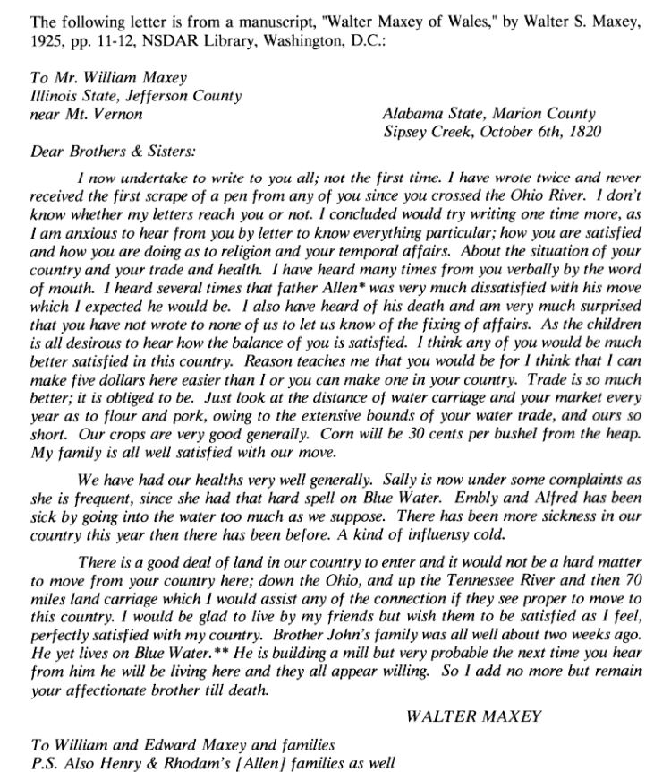

Children of Walter and Sarah (Allen) Maxey:
+ 8431. ALLEN MAXEY, b. 31 Aug. 1796, Tenn.; d. bet. 1861-66. Tenn.
+ 8432. EDWARD MAXCY, b. 2 July 1798, Tenn.; d. 2 Feb. 1860, Miss.
+ 8433. ELIZABETH P. MAXEY, b. 18 Mar. 1800, Tenn.; d. bet.1850-60, prob. Pulaski Co., Mo.; m. Nicholas Welch.
+ 8434. MARY N. MAXEY, b. 12 Jan. 1803, Tenn.; d. 1873, Marion Co., Ark.; m. Abner Cantrell.
+ 8435. WILLIAM M. MAXEY, b. 24 Sept. 1805, Tenn.; d. 16 Oct. 1843, Mo.
8436. EMILY G. MAXEY, b. 8 Feb. 1808, Tenn.; d. bet.1850-60, Itawamba Co., Miss.; m. James McNeace.
+ 8437. ALFRED MAXEY, b. 10 Aug. 1810, Tenn.; d. bet.1860-70, prob. Lafayette Co., Ark.
8438. SARAH MELISSA MAXEY, b. 5 Apr. 1812, Tenn.; m. Charles Willis.
- 8439. LETHA M. MAXEY, b. 14 Jan. 1814, Tenn.; d. bet.1870-79, Pulaski Co., Mo.; m. John Nelson, Jr. + 8430. HENRY D. MAXEY, b. 23 July 1816, Lauderdale Co., Ala.; d. 1870, Laclede Co., Mo.
- 8431. JOHN WALTER G. MAXCY, b.‘28 Oct. 1821, Monroe Co., Miss.; d. 15 Mar. 1877, Lee Co., Miss.

I am descended from Edward Maxcy (he incorrectly spelled his name with a “c” – this was later corrected by his grandson, Calhoun Walker Maxey). Edward Maxey was born in 1798 and died in 1860. He was the son of Walter and Sarah (Allen) Maxey. He was born on 2 July 1798 in Tennessee but lived with his parents in Lauderdale County, Alabama, in 1818 when he served as a lieutenant in the local militia. The Maxeys were still living there on 20 February 1820 when his deposition as a witness in a court case was ordered to be taken by a judge in Lawrence County, Tennessee.

On 14 January 1821, in Lawrence County, Tennessee, Edward married Mary "Polly" Nelson (born 1805, Buncombe County, North Carolina), a daughter of John and Jane (Montgomery) Nelson, Sr. (Edward’s younger brother William married Mary’s sister Sarah in that county five years later.)

In 1823, Edward applied for U.S. Government land in Marion County, Alabama, and he received 80 acres in Township 13, Range 16 West, which was patented on 2 October 1824.2 In 1826, he applied for additional land in the same location.

Edward was head of household in the 1830 census of Marion County. Still, the family moved across the border to Itawamba County, Mississippi, in 1836, where he remained until his death on 2 February 1860. On 6 August 1879, Mary Maxcy, widow of Edward, applied for a pension, claiming that her husband had served during the War of 1812 in Captain Rielers Company of Tennessee Militia. She said he enlisted in Lauderdale County, Tennessee (that county was not formed until 1835), at about age 20 and that he had married her (maiden name Nelson) in Lawrence County, Tennessee, on 18 January 1821. They moved to Marion County, Alabama, and then to Itawamba County, Mississippi, in 1836. Her claim was rejected as there was no such company during that war. We have noted his service in the militia in Lauderdale County, Alabama, in 1818.

Edward Maxcy left a will dated 3 January 1860 and proved on 27 February.4 But when Mary died on 26 November 1881, five pieces of real estate not specifically devised by Edward in his will and the personal estate left to her remained. It, therefore, became necessary for the heirs to force a division of the estate after her death through a suit brought before the Chancery Court in April of the following year. Among the many papers involved in the settlement of this suit was a copy of Edward’s will. By 1882, only four of the 12 children of Edward and Mary were still living: Andrew, Isabella, Mary Caroline, and George. Although daughter Arminda Wallace was deceased by 1882, her heirs didn’t enter into the suit as Edward had made a special provision that the land he left to her in his will would not be subject to accounting in the final settlement.
Edward had kept careful records of the personal and real property and cash that he had already given to each of his children: Mrs. Sarah Jane Kelso, Mrs. Angeline Martin, E.N. Maxcy, George W. Maxcy, Isabella Hood, F.M. Maxcy, A.J. Maxcy, Mrs. Caroline Owen, J.N. Maxcy, William H. Maxcy, and Edward C. Maxcy.

The advancements in land given were the same as devised in his will and he directed that each child’s share should be made equal after the death of his wife. Therefore, the court directed that his four surviving children should receive one-tenth; and the heirs of his deceased children should receive a portion of one-tenth, i.e., the children of Mrs. Sarah Jane Kelso — Mrs. Mary E. Carothers, Letha A. Pearce, R.S. Kelso, Desdemona C. Nabers, John W. Kelso, Isaac N. Kelso and Hugh A. Kelso; the children of Mrs. Angeline Martin -- Edward Martin and Lizzie Patton; the children of F.M. Maxcy — Thomas F. and Rutha Maxcy; the children of J.N. Maxcy — V.B. Maxcy, B.G. Maxcy, John N. Maxcy, Mrs. Mary Truelove and Mrs. Desdemona Chaffin; the children of W.H. Maxcy — Mrs. L.A. Chaffin, John Maxcy, Mary Maxcy, Mrs. Jane Williams and Mrs. Rena (Runa) Jordan; and the children of E.C. Maxcy - Mrs. M.C. Perkins and Mrs. Ella Pearce (Pierce).
The residences of the above persons were given at that time as: George W. Maxcy of Lewisburg, Conway County, Arkansas; Edward Martin and Mrs. Lizzie Patton of Franklin, Robertson County, Texas; Mrs. Jane Williams, Leesville, Gonzales County, Texas; Mrs. Runa Jordan of Childers Station, Cherokee Nation, Indian Territory; R.S. Kelso of Noxubee County, Mississippi; Mrs. Desdemona Nabers, John W. Kelso, Isaac N. Kelso and Mrs. Desdemona Chaffin of Monroe County, Mississippi; V.B. Maxcy, B.G. Maxcy, John N. Maxcy, Mrs. Mary Truelove, Mrs. Ella Pearce, Mrs. L.A. Chaffin, Mrs. Mary Maxcy, John Maxcy, Mrs. Mary E. Carothers, Mrs. Letha A. Pearce, Hugh A. Kelso (a minor, whose parents were dead); and Thomas F. and Rutha Maxcy (minors, who resided with their mother, Mrs. Jeanetta Cain), all of Itawamba County, Mississippi. (John Maxcy’s residence was given in another place as Tishomingo County, Mississippi)
We note, upon reading the will of Edward Maxcy, that a bequest to his son William was seemingly inadvertently omitted, although he was listed in his father’s record book (showing Edward had given him land valued at $2,000); and in the division by the court it said: "W.H. Maxcy, dec’d. who was a son of said testator."
Son Elihu had enlisted in the Confederate Army on 10 November 1863 and served as a private in Company E, 3rd Mississippi Infantry. He was captured at Marietta, Georgia, on 3 July 1864 and died of smallpox on the 7th or 8th of October 1864. He was buried near Camp Davis.
Son William also fought for the Confederacy and had served as a private in French’s Company, 4th Alabama (Roddey’s) Cavalry. Records indicated that his residence was in Itawamba County and that he was captured on 28 February 1863 in Marion County, Alabama. On 12 May there was a notation of a payment for his coffin and burial.
It is probable that a third son, Francis Marion, also served in the Confederate Army in Company F, 24th Mississippi Infantry. However the widow of another man who had the same name but was born and lived in Georgia and then in Texas claimed this service. Edward’s son Francis was of an age to have been in the war, and the service record says that the person by that name enlisted on I September 1861 in Fulton, Itawamba County. Francis, son of Edward, died between the 1870 census and 1874 and it has been said he was shot and killed by a brother-in-law. His widow Jeanetta married James Cain on 23 July 1874. Francis left two children: Thomas F. and Rutha.

Children of Edward and Mary (Nelson) Maxcy
- 84321. JOHN NELSON MAXCY, b. 1821, Marion Co., Ala.; d. bet. 1855-58, Itawamba Co., Miss.
- 84322. WILLIAM H. MAXCY, b. 1824, Marion Co., Ala.; d. May 1863.
845
♦ 84323. SARAH JANE MAXCY, b. 1826, Marion Co., Ala.; d. 2 Apr. 1868, Itawamba Co., Miss.; m. Isaac H. Kelso.
- LETHA ANGELINE MAXCY, b. 1829, Marion Co., Ala.; d. before 1870, Itawamba Co., Miss.; m. Dr. Cyrus J. Martin. Children living with parents in the 1860 census: Edward M., b. 1851; Columbus L., b. 1854, who d. bet. 1870-1882; and Mary Elizabeth, b. 1857. They were living in Itawamba Co., Miss., in the 1870 census with Edward and Elizabeth Martin.
- MARY CAROLINE "CALINE" MAXCY, b. 24 July 1830 (?1828), Marion Co., Ala.; d. 20 Dec. 1903, Union Co., Miss.; m. (1) 2 Mar. 1847, Itawamba Co., Miss., Hugh Walker, and (2) 10 Aug. 1858, Tippah Co., Miss., Oswell H. Owen (b. 12 Mar. 1838, d. 22 Aug. 1892). Children of 1st mar.: Laura Ann, b. 17 Aug. 1860, Tippah Co., Miss., d. 17 Jan. 1919, Union Co., Miss., m. James Monroe Harris (b. 12 June 1856, d. 29 May 1944); and Samantha A., b. 1867, Tippah Co., Miss. Children of 2nd mar.: Amanda J., b. 1851, who m. Redon N. Stephens; and John C.C., b. 1857.
+ 84326. EDWARD CALHOUN MAXCY, b. 4 Oct. 1832, Marion Co., Ala.; d. ca.1858, Itawamba Co., Miss.
- ELIHU N. MAXCY, b. 1834, Marion Co., Ala.; d. Oct. 1864. Did not marry.
- GEORGE W. MAXCY, b. 1838, Itawamba Co., Miss.; m. 13 Aug. 1860, Itawamba Co., Miss., Nancy Jane Holder.
- FRANCIS "FRANK" MARION MAXCY, b. 1840, Itawamba Co., Miss.; d. bet. 1870-74; m. 1 Jan. 1868, Itawamba Co., Miss., Jeanetta J. Shaw. Children: Thomas F., b. ca.1869; and Rutha, b. ca.1870.
- ISABELLA MAXCY, b. 1842, Itawamba Co., Miss.; m. William Hood. Children: Mary, Henry J. and Roxy.
+ 84321. ANDREW JACKSON MAXCY, b. 8 Apr. 1845, Itawamba Co., Miss., d. 15 Oct. 1895, Itawamba Co., Miss.
84322. ARMINDA MAXCY, b. 1848, Itawamba Co., Miss.; d. ca.1880; m. 20 Feb. 1866, Itawamba Co., Miss., David C. Wallace. Children: John E., b. 1867; Dora, b. 1868; Lavinia, b. Jan. 1870; Newman, b. 1875; Clopton, b. 1877; and James, b. Mar. 1880.

84321. ANDREW J. MAXCY
(1845-1895)

I am descended from Andrew Jackson Maxcy. My grandfather, Calhoun Walker Maxey, corrected the spelling of the Maxey name by going to a cemetery where Walter Maxey was buried in Itawamba County, Mississippi.

Andrew Jackson Maxcy, a son of Edward and Mary (Nelson) Maxcy, was born on 8 April 1845 in Itawamba County, Mississippi. He grew up on his parents’ farm in Township 10 in Itawamba County, located near Reed’s Creek (originally called Maxcy’s Creek.).
On 8 September 1863, Andrew enlisted in the Confederate Army and served in Company C, 6th Mississippi Cavalry for a short time. On 6 November 1864, in Itawamba County, Andrew married Nancy M.L. Stephens (born ca.1845), and they had ten children, all of whom grew to maturity.

Andrew died on 15 October 1895 and is buried at the Maxcy Cemetery, about five miles south of Fulton. The widow Nancy died on 6 September 1915, in Meridian, Lauderdale County, Mississippi. Their son Harold is also buried in Maxcy Cemetery. Andrew and Nancy’s children William, Walter, and Calhoun are buried at Union Grove Cemetery; Ruberter is buried at Harden Church Cemetery; Nora is buried at Ridge Cemetery in Itawamba County just west of Red Bay, Alabama; Emma R. is buried at New Home Cemetery; Otis is buried at Clover Ridge Cemetery; and Margie is buried at Mt. Enon Cemetery near Plant City, Florida.

Son Walter J. and his first wife, Docia, had two children: Ida D., born 15 April 1899, died 12 November 1981, who married Bula W. McFadden on 8 June 1919, Itawamba County; and Henry Porter, born 8 February 1902, died 20 August 1954, who married Elsie Riggs, 7 February 1926, Itawamba County. Walter and his second wife, Elizabeth, had: Elzie A., born 6 October 1920, who married Lucille Lindsay; Ernest, born 9 January 1928, who married Christine Aust, 11 February 1946; and Walter Joshua, born 14 July 1930.

Children of Andrew J. and Nancy M.L. (Stephens) Maxcy

843211 WILLIAM F. MAXCY, b. 22 Apr. 1866, Itawamba Co., Miss.; d. 12 Dec. 1915, Monroe Co., Miss.; m. 24 Dec. 1893, Itawamba Co., Miss., Sarah C. Bowen.
843212MARGIE LOUELLA MAXCY, b. 8 Apr. 1868, Itawamba Co., Miss.; d. 9 June 1950, Plant City, Fla.; m. 12 Feb. 1888, Itawamba Co., Miss., Wesley Monroe Gaddy.
843213 HAROLD PORTER MAXCY, b. 14 Feb. 1870, Itawamba Co., Miss.; d. 20 Nov. 1898, Itawamba Co., Miss.; m. 1 Dec. 1895, Itawamba Co., Miss., Mary R. Bowen (b. 11 Feb. 1867, d. 3 Apr. 1910), d/o Richard & Martha A. Bowen. Child: Vista, b. Oct. 1896.
843214 RUBERTER MAXCY, b. 26 Feb. 1872, Itawamba Co., Miss.; d. 13 Dec. 1955, Itawamba Co., Miss.; m. 26 Mar. 1892, Itawamba Co., Miss., John Robertson Pierce* (b. 18 Jan. 1859, d. 23 Oct. 1930). Children, all born Itawamba County: Prentiss H., b. 18 May 1893, d. 22 Sept. 1976, m. 9 Feb. 1926, Trudy Hardin (b. 11 June 1896, d. 28 Dec. 1972); Lorene, b. 29 Oct. 1895, d. 2 Nov. 1958, m. 27 Dec. 1914, Itawamba Co., Miss., Henry Penn Hankins (b. 18 July 1890, d. 15 Oct. 1945, Lee Co., Miss.); Callie Pernie, b. 12 May 1898, d. 4 Oct. 1957, Lee Co., Miss., m. Fred Ramsey; Napoleon Bonaparte, b. 29 Jan. 1901, d. 1 Jan. 1973, Shelby Co., Tenn., m. Audra Summerford (b. 13 Aug. 1908); and Essie Mae, b. 26 Dec. 1907, m. 15 Dec 1928, Lee Co., Miss., Claude Watson Allred (b. 3 Dec. 1906, Lee Co., Miss., d. 10 July 1944, Lee Co., Miss.).
843215 NORA ANTHEM MAXCY, b. 4 Mar. 1874, Itawamba Co., Miss.; d. 1 May 1960; m. (1) 25 Dec. 1898, Itawamba Co., Miss., Wood A. Wallace, and (2) 6 Dec. 1917, Itawamba Co., Miss., Hubbart Allen Trulove.
843216 EMMA RENA MAXCY, b. 25 Dec. 1875, Itawamba Co., Miss.; d. 13 Dec. 1953, Itawamba Co., Miss.; m. 21 Nov. 1895, Itawamba Co., Miss., James Albert Moore (b. 20 Feb. 1874, d. 2 Aug. 1955). Children: Viola, b. 10 Oct. 1896, m. Curtis Spencer; Eula, b. 17 Jan. 1899, m. Ira Roberts; Beulah, b. 28 Mar. 1901, m. Melvin Roberts; Ozell, b. 7 Sept. 1903, m. 26 Oct. 1919, Ezell Roberts; Shelby, b. 23 Oct. 1905, m. Vermon Wheeler; Luther, b. 5 Sept. 1908, m. Jessie Roberts; Burdean, b. 26 May 1911, m. Lee Watts; and Erlene, b. 26 June 1914, m. Ellis Smith.
843217 WALTER J. MAXCY, b. 13 Apr. 1877, Itawamba Co., Miss.; d. 28 Feb. 1930; m.(1)4 June 1898, Itawamba Co., Miss., Docia Brown, and (2) 29 Aug. 1918, Itawamba Co., Miss., Elizabeth "Lizzie" Lee Shaw.
843218. CALHOUN WALKER MAXCY (later Maxey), b. 23 Apr. 1880, Itawamba Co., Miss.; d. 10 May 1963, Walker Co., Ala.
843219. A.B. (OTIS) MAXCY, b. 1 Mar. 1882, Itawamba Co., Miss.; d. 29 Dec. 1932; m. 17 Nov. 1907, Itawamba Co., Miss., Vercie Justice (b. 23 Dec. 1892, d. 10 Jan. 1962).
843210. CALDONIA D. MAXCY, b. 20 Dec. 1883, Itawamba Co., Miss.; d. 15 Jan. 1984, Brandon, Miss.; m. 30 Oct. 1904, Itawamba Co., Miss., J. Walter Chamblee.

Calhoun Walker Maxey

I am descended from Calhoun Walker Maxey. My father, Andrew Jackson Maxey, who was born in 1880 and died in 1963. Calhoun Walker Maxey*, was the son of Andrew J. and Nancy M.L. (Stephens) Maxcy, and he was born on 23 April 1880, in Itawamba County, Mississippi. (Curiously, the 1880 census of that county identified this child as Lafayette.) On 22 December 1900, in Itawamba County, Walker married Pernia "Pernie" Jane Webb (born 2 September 1878), a daughter of David D. and Nancy (Ford) Webb. Pernie died on 1 August 1948, and Walker died on 10 May 1963 in Walker County, Alabama. They are buried in Union Grove Cemetery in the Tildon Community of Itawamba County with their son David. My father, Jack Maxey, is buried at Woodlawn Cemetery in Grenada, Mississippi, and Ellis Maxey is buried at Memory Hill Gardens in Tuscaloosa, Alabama.

Children of C. Walker and Pernia J. (Webb) Maxey:
8432181. JOHN ELLIS MAXEY, b. 30 Nov. 1901, Itawamba Co., Miss.; d. 7 June 1985, Tuscaloosa Co., Ala.; m. 24 May 1941, Guilford Co., N.C., Grace Katherine Rodman (b. 31 Aug. 1913, Chester Co., S.C.).
8432182. ETHEL "EVIE" MAXEY, b. 18 Aug. 1903, Itawamba Co., Miss.; d. 2 Feb. 1962, Itawamba Co., Miss.; m. Clyde Vernon Lyle.
8432183. ESTELLE MAXEY, b. 8 Aug. 1905, Itawamba Co., Miss.; m. 25 July 1925, Robert Coin Sample.
8432184. DAVID DEE MAXEY, b. 13 Dec. 1907, Itawamba Co., Miss.; d. 16 Mar. 1925.
8432185. JEWEL PAULINE MAXEY, b. 20 Aug. 1910, Itawamba Co., Miss.; m. Joseph Bradford Jackson.
8432186. WILLIE MAE MAXEY, b. 1 Sept. 1912, Itawamba Co., Miss.; m. Euel Verter Davis.
8432187. MAURINE MAXEY, b. 24 June 1915, Itawamba Co., Miss.; m. 22 Sept. 1934, Calhoun Co., Miss., Rufus Anderson.
8432188. ANDREW JACKSON "JACK MAXEY, b. 10 May 1918, Itawamba Co., Miss.; d. 4 Feb. 1958, Grenada, Miss.; m. Marie Carpenter.
8432189. NANCY CUMI MAXEY, b. 19 Jan. 1920, Itawamba Co., Miss.; m. 22 June 1941, Eupora, Miss., John Duke Lippincott.
8432180. EARL WEBB MAXEY, b. 31 Mar. 1923, Itawamba Co., Miss.; m. 12 July 1947, Bellefontaine, Miss., Ruby Lee Knight.

Note: Calhoun W. was born a Maxcy but adopted the spelling "Maxey" as given on the tombstone of his great-grandfather, Walter Maxey.
Family records supplied by the late J. Ellis Maxey of Tuscaloosa, Ala.

Andrew Jackson Maxey

84321881 HUGH IRBY MAXEY, b
84321882 WILLIAM LARRY MAXEY, b.
84321883 ANDREW MICHAEL MAXEY, b. November 4, 1952 in Grenada, MS.

Andrew Michael Maxey

I was born on November 4, 1952, in Grenada, Mississippi. I was the third and youngest child of Jack and Marie Maxey. I left Mississippi in 1974 to serve in the Peace Corps in Brazil and then went on to a career in the foreign service. I currently reside in Fairfax, Virginia. I was previously married to Judy Kuhn. We divorced in 1985 after three years of marriage, we had no children. I married Ana Julia Toro on July 14, 1990, in Tegucigalpa, Honduras, and we have three children.

Andrew Michael Maxey

843218831 – Dominique Michelle Maxey – born in Tegucigalpa, Honduras on November 10, 199. Married Matthew Vega on in Chicago, IL.
843218832 – Andrew Jackson Maxey III – born in San Jose, Costa Rica on July 28, 1993. Married Rebecca Dawn McCormick-Goodhart on in Franklin, Virginia.
843218833 – Justin Alexander Maxey – born in Lima, Peru, on June 5, 1997.

Andrew Jackson Maxey III

8432188311 – Ariana Shalom Maxey, born in Christiansburg, VA
8432188312 – Maverick Wilder Maxey, born in Dallas, TX
8432188312 – Lively Violet Maxey, born in Dallas, TX.

Clark, Edythe Maxey, “The Maxeys of Virginia” published in three editions by Gateway Press, Baltimore, 2000.
Quitt, Martin & Dictionary of Virginia Biography. William Byrd (ca. 1652–1704). (2020, December 07). In Encyclopedia Virginia. https://encyclopediavirginia.org/entries/byrd-william-ca-1652-1704. William Byrd I was an influential figure in 17th-century colonial Virginia. As a planter, Byrd amassed nearly 30,000 acres of land through the headright system. This system granted landowners 50 acres for each indentured servant they brought to the colony. Byrd utilized this to import servants and slaves, both to work his fields and to resell to other planters.
Morant, Philip. The history and antiquities of the county of Essex. Compiled from the best and most ancient historians. Vol. 2.. London: printed for T. Osborne; J. Whiston; S. Baker; L. Davis and C. Reymers; and B. White, 1768. Eighteenth Century Collections Online (accessed October 28, 2024). https://link.gale.com/apps/doc/CW0102907258/ECCO?u=viva_gmu&sid=primo&xid=f66d9306&pg=1 .
Henrico County, Virginia, Minute Book, 1719-1724, p. 56.

